[CEN 323 ] Computer Organization & Assembly Language
Lab 8 Journal

Name : Fatima Asad
Enrollment Number: 01-135232-020

Lab Deliverables (submission guideline)

Create a folder named after your enrollment number and add the following files:
  - Create a folder named YourRollNumber_Lab8 containing:
- .asm files of the three practice tasks.
- 4 .asm files of the mid term exam
- Add full screen screenshots of the code and output in this word file.
  - Zip the Folder and upload to LMS.

Mid Term Exam Tasks

Question No. 1.
Write a program in assembly language that takes a single digit number from the user ;
- If the number >= 5:
  - Check if the number is even, if it is even, divide it by 2 and print the result.
  - If it is odd, multiply it with 2 and print the result (If the multiplication result is two digits, print it accordingly)

- If the number < 5: Message is displayed, “Number is less than 5”.

Code (TEXT):
.model small
.data
str1 db "Enter a single digit number: $"
str2 db 0Ah,0Dh,"Number is less than 5$"
str3 db 0Ah,0Dh,"Result: $"

.code
start:
mov ax,@data
mov ds,ax

lea dx,str1
mov ah,9
int 21h

mov ah,1
int 21h
sub al,48

mov bh,al
cmp bh,5
jl lessThan

test bh,1
jnz oddCase

evenCase:
lea dx,str3
mov ah,9
int 21h

mov al,bh
shr al,1
add al,48

mov dl,al
mov ah,2
int 21h
jmp finish

oddCase:
mov al,bh
mov ah,0
mov cl,2
mul cl

mov bh,al

lea dx,str3
mov ah,9
int 21h

cmp bh,9
jg doubleDigit

mov dl,bh
add dl,48
mov ah,2
int 21h
jmp finish

doubleDigit:
mov al,bh
mov ah,0
mov cl,10
div cl

mov bl,ah

mov dl,al
add dl,48
mov ah,2
int 21h

mov dl,bl
add dl,48
mov ah,2
int 21h
jmp finish

lessThan:
lea dx,str2
mov ah,9
int 21h

finish:
mov ah,4ch
int 21h

Screenshot (CODE):
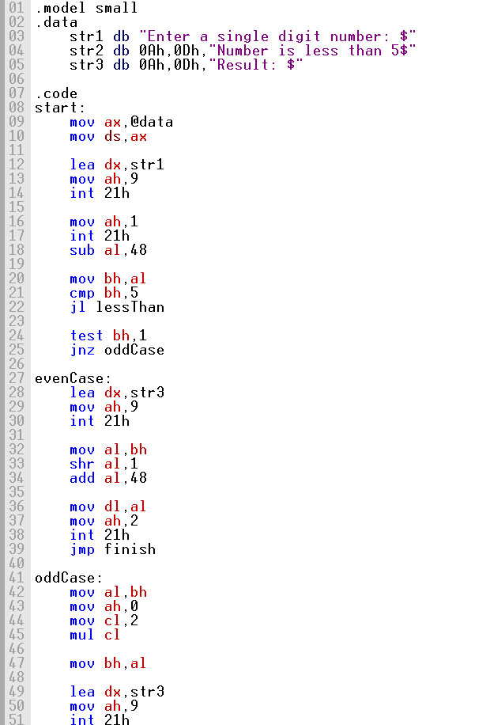

Screenshot (OUTPUT):
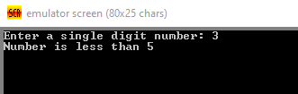
Question No. 2.
Write program in Assembly language that takes a single digit input from user. After taking input, print on screen the letter grade. The program should keep asking for another number in a loop to check the grade of the next student , until the enter key is pressed.
Grading policy is:
8 to 10 | A
5 to 7 | B
3 to 4 | C
< 4 | F
< 0 & > 10 | Invalid input

Code (TEXT):
.model small

.data
str1 db "Enter number : $"
str2 db 0Ah,0Dh,"Invalid number : ",10,13,"$"
str3 db 0Ah,0Dh,"Grade is F ",10,13,"$"
str4 db 0Ah,0Dh,"Grade is C ",10,13,"$"
str5 db 0Ah,0Dh,"Grade is B ",10,13,"$"
str6 db 0Ah,0Dh,"Grade is A ",10,13,"$"
str7 db 0Ah,0Dh,"You pressed Enter key ",10,13,"$"
num db ?

.code
main:
mov ax,@data
mov ds,ax

loopStart:

mov ah,09h
lea dx,str1
int 21h

mov ah,01h
int 21h

cmp al,13
je exitLoop

sub al,48

cmp al,0
jl invalidCase

cmp al,10
ja invalidCase

cmp al,3
jl gradeF

cmp al,4
jle gradeC

cmp al,7
jle gradeB

mov ah,09h
lea dx,str6
int 21h
jmp continueLoop

gradeB:
mov ah,09h
lea dx,str5
int 21h
jmp continueLoop

gradeC:
mov ah,09h
lea dx,str4
int 21h
jmp continueLoop

gradeF:
mov ah,09h
lea dx,str3
int 21h
jmp continueLoop

invalidCase:
mov ah,09h
lea dx,str2
int 21h

continueLoop:
jmp loopStart

exitLoop:
mov ah,09h
lea dx,str7
int 21h

mov ah,4Ch
int 21h
end main

Screenshot (CODE):
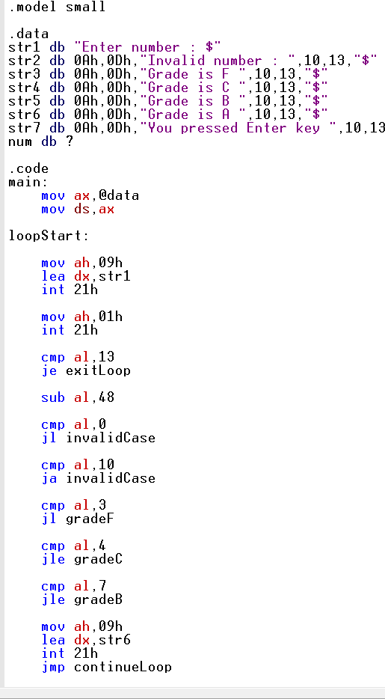

Screenshot (OUTPUT):
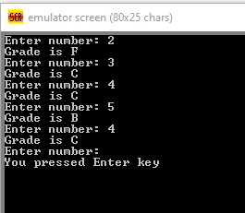
Question No. 3
Write a program in assembly language that takes a single digit number from the user.
- If the input is divisible by 2: User is asked to enter another number, and the sum of both numbers is displayed with an appropriate message. (If the sum is of two digits, print it accordingly)
- If the input is not divisible by 2: Multiply it with 2 and print the result with an appropriate message. (If the Multiplication result is of two digits, print it accordingly)

Code (TEXT):
.model small
.data
str1 db "Enter first number: $"
str2 db 0Ah,0Dh,"Enter second number: $"
str3 db 0Ah,0Dh,"Sum of two numbers: $"
str4 db 0Ah,0Dh,"Multiplication of two numbers: $"

.code
main:
mov ax,@data
mov ds,ax

lea dx,str1
mov ah,9
int 21h

mov ah,1
int 21h
sub al,48
mov bh,al

test bh,1
jnz oddCase

evenCase:
lea dx,str2
mov ah,9
int 21h

mov ah,1
int 21h
sub al,48

add al,bh
mov bh,al

lea dx,str3
mov ah,9
int 21h

cmp bh,9
jg twoDigitSum

mov dl,bh
add dl,48
mov ah,2
int 21h
jmp exitProgram

twoDigitSum:
mov al,bh
mov ah,0
mov cl,10
div cl

mov bl,ah

mov dl,al
add dl,48
mov ah,2
int 21h

mov dl,bl
add dl,48
mov ah,2
int 21h
jmp exitProgram

oddCase:
mov al,bh
mov ah,0
mov cl,2
mul cl

mov bh,al

lea dx,str4
mov ah,9
int 21h

cmp bh,9
jg twoDigitMul

mov dl,bh
add dl,48
mov ah,2
int 21h
jmp exitProgram

twoDigitMul:
mov al,bh
mov ah,0
mov cl,10
div cl

mov bl,ah

mov dl,al
add dl,48
mov ah,2
int 21h

mov dl,bl
add dl,48
mov ah,2
int 21h

exitProgram:
mov ah,4ch
int 21h

end main

Screenshot (CODE):
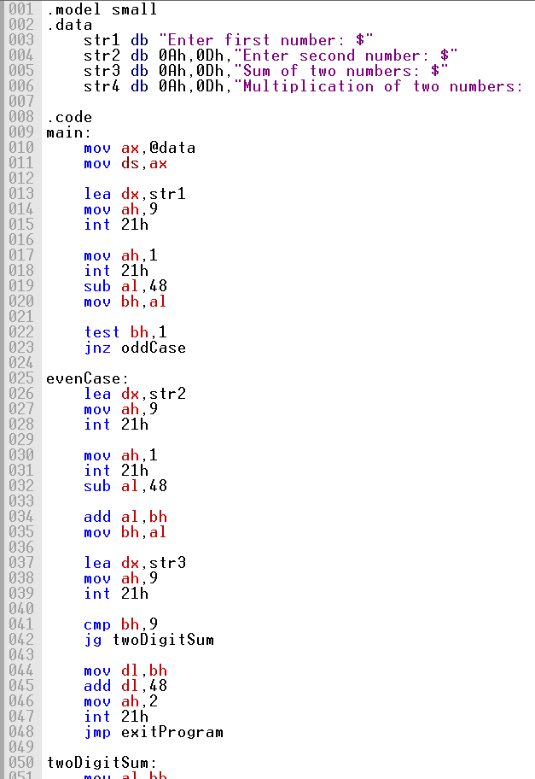

Screenshot (OUTPUT):
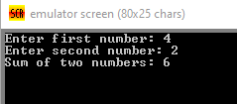
Question No. 4
Implement a switch-case statement in assembly language to determine the day of the week based on a user input. The program should prompt the user to enter a number between 1 and 7 and then print out the corresponding day of the week (e.g. "Monday", "Tuesday", etc.).
- First day of the week is Monday for the sake of this exam.
- In case the number is 0 or greater than 7, print “Invalid Input”

Code (TEXT):
.model small
.data
str1 db "Enter a number: $"
str2 db 0Ah,0Dh,"Day is: $"
str3 db "Monday$"
str4 db "Tuesday$"
str5 db "Wednesday$"
str6 db "Thursday$"
str7 db "Friday$"
str8 db "Saturday$"
str9 db "Sunday$"
str10 db "Invalid Input$"

.code
main:
mov ax,@data
mov ds,ax

lea dx,str1
mov ah,9
int 21h

mov ah,1
int 21h
sub al,48
mov bh,al

lea dx,str2
mov ah,9
int 21h

cmp bh,1
je monday
cmp bh,2
je tuesday
cmp bh,3
je wednesday
cmp bh,4
je thursday
cmp bh,5
je friday
cmp bh,6
je saturday
cmp bh,7
je sunday
jmp defaultCase

monday:
lea dx,str3
mov ah,9
int 21h
jmp exitProgram

tuesday:
lea dx,str4
mov ah,9
int 21h
jmp exitProgram

wednesday:
lea dx,str5
mov ah,9
int 21h
jmp exitProgram

thursday:
lea dx,str6
mov ah,9
int 21h
jmp exitProgram

friday:
lea dx,str7
mov ah,9
int 21h
jmp exitProgram

saturday:
lea dx,str8
mov ah,9
int 21h
jmp exitProgram

sunday:
lea dx,str9
mov ah,9
int 21h
jmp exitProgram

defaultCase:
lea dx,str10
mov ah,9
int 21h

exitProgram:
mov ah,4ch
int 21h

end main

Screenshot (CODE):
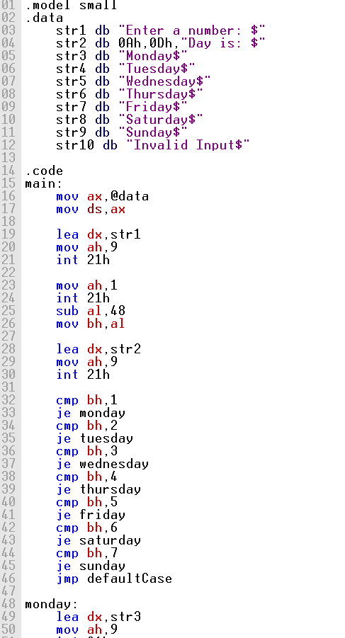

Screenshot (OUTPUT):
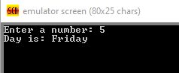

Lab Task

Task 1:
Code (TEXT):
.model small
.data
str1 db "Enter 10 numbers: $"
str2 db 10,13,"No of even numbers: $"
str3 db 10,13,"No of odd numbers: $"
str4 db 10,13,"Even numbers are more$"
str5 db 10,13,"Odd numbers are more$"
str6 db 10,13,"Enen and Odd are equal$"
nums db 10 dup(?)
evenCount db 0
oddCount db 0

.code
main:
mov ax,@data
mov ds,ax

lea dx,str1
mov ah,9
int 21h

mov si,0
mov cx,10

readLoop:
mov ah,1
int 21h
sub al,48

mov nums[si],al
inc si
loop readLoop

mov si,0
mov cx,10

countLoop:
mov al,nums[si]
mov ah,0
mov bl,2
div bl

cmp ah,0
jne oddCase

inc evenCount
jmp nextStep

oddCase:
inc oddCount

nextStep:
inc si
loop countLoop

lea dx,str2
mov ah,9
int 21h

mov dl,evenCount
add dl,48
mov ah,2
int 21h

lea dx,str3
mov ah,9
int 21h

mov dl,oddCount
add dl,48
mov ah,2
int 21h

mov al,evenCount
cmp al,oddCount
jg moreEven
jl moreOdd

lea dx,str6
mov ah,9
int 21h
jmp exitProgram

moreEven:
lea dx,str4
mov ah,9
int 21h
jmp exitProgram

moreOdd:
lea dx,str5
mov ah,9
int 21h

exitProgram:
mov ah,4ch
int 21h

Screenshot (CODE):
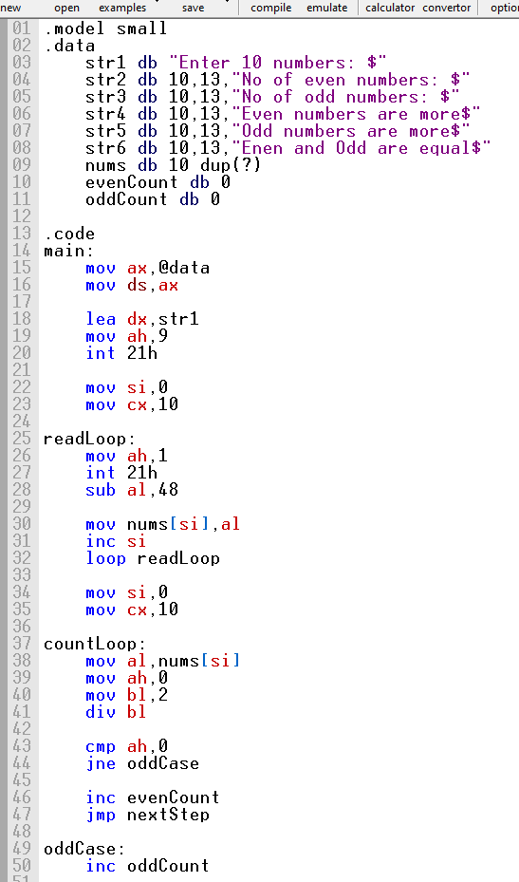

Screenshot (OUTPUT):
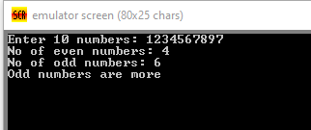

Task 2:
Code (TEXT):
.model small
.data
str1 db "Enter 5 numbers: $"
str2 db 10,13,"Array in reverse: $"
nums db 5 dup(?)

.code
main:
mov ax,@data
mov ds,ax

lea dx,str1
mov ah,9
int 21h

mov si,0
mov cx,5

readLoop:
mov ah,1
int 21h
sub al,48

mov nums[si],al
inc si
loop readLoop

lea dx,str2
mov ah,9
int 21h

mov si,4
mov cx,5

printLoop:
mov dl,nums[si]
add dl,48
mov ah,2
int 21h

dec si
loop printLoop

mov ah,4ch
int 21h

end main

Screenshot (CODE):
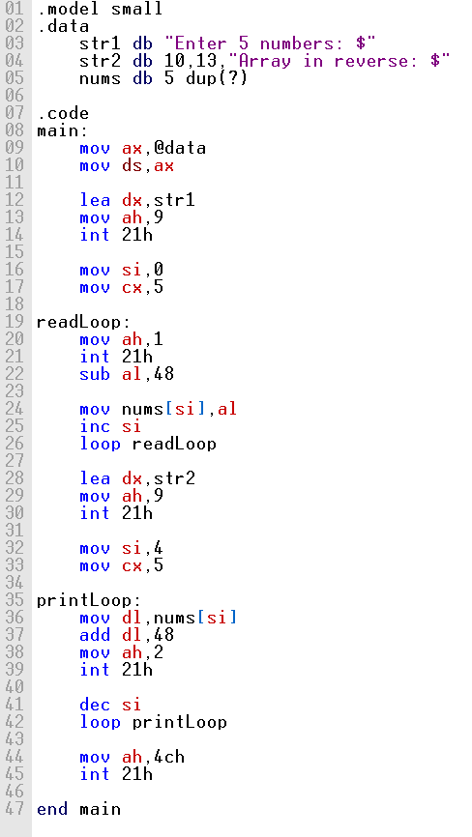

Screenshot (OUTPUT):
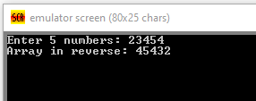

Task 3:
Code (TEXT):
.model small

.data
nums db 5 dup(?)
abc1 db "Enter 5 number: $"
abc2 db 0Dh,0Ah,"Nubers in desc order: $"

.code
main proc
mov ax, @data
mov ds, ax

mov ah, 09h
lea dx, abc1
int 21h

mov cx, 5
lea bx, nums

readLoop:
mov ah, 01h
int 21h
sub al, '0'

mov [bx], al
inc bx
loop readLoop

mov cx, 5

outerLoop:
dec cx
jz finish

lea bx, nums
mov di, cx

innerLoop:
mov al, [bx]
mov dl, [bx+1]

cmp al, dl
jge skipSwap

mov [bx], dl
mov [bx+1], al

skipSwap:
inc bx
dec di
jnz innerLoop

jmp outerLoop

finish:
mov ah, 09h
lea dx, abc2
int 21h

mov cx, 5
lea bx, nums

printLoop:
mov dl, [bx]
add dl, '0'
mov ah, 02h
int 21h

mov dl, ' '
int 21h

inc bx
loop printLoop

mov ah, 4Ch
int 21h

main endp
end main

Screenshot (CODE):
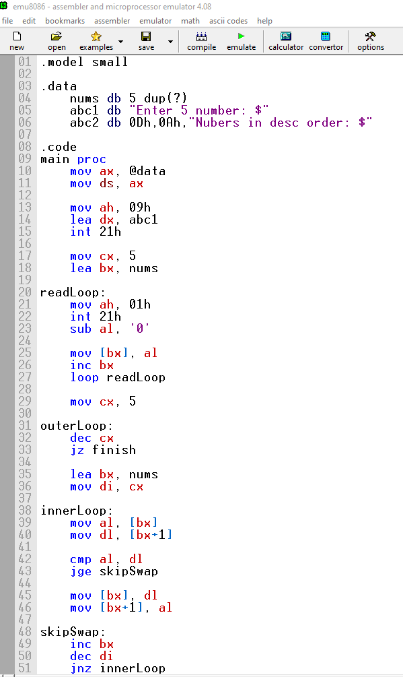

Screenshot (OUTPUT):

